Credit Card Fraud

Introduction
Fraud detection is immensely important to large corporations, especially in the banking and financial industries. In 2024 the FTC reported fraud losses increased to $12.5 Billion^{[1]}. Looking at the credit card portion of the $12.5 Billion it is estimated that 62 million individuals experienced some sort of fraudulent transaction^{[2]}. The goal of the project is to identify these fraudulent transactions.
The main consumer for this project would be credit card companies and banks. Both entities have a financial incentive to quickly identify fraudulent transactions as quickly as possible. If done quickly enough, it would be possible to block the transaction at the point of sale, thus preventing the loss of those funds by either the merchant or the credit card company or bank. Other potential consumers for the project, with some slight modifications, would be telecommunication companies. These companies are tasked with finding and preventing fraudulent calls on their networks. The model developed here would require some modifications to accommodate the different patterns.

Data Overview
The data used in the proof of concept model was obtained from Kaggle (link). The data gathered is a series of approximately 550,000 credit card transactions. The data is from European transactions in 2023. The data has been anonymized so no personally identifiable information is present in the data set (see Ethical Discussion for more details). The data contains a unique ID, twenty-eight anonymized feature columns labeled V1-V28, a column for the amount of the transaction, and a class column that represents if the transaction was fraudulent.

Data exploration
The first step in performing an analysis is exploring the raw data. Since this data set contains a unique ID column that was removed to facilitate exploration and modeling. This column does not have any value to the model. Next the twenty-nine remaining features, V1-V28 and Amount, were then checked for missing values. Since none of the features contained missing values were found, there is no need to consider various methods for handling the missing values.
Once the data was cleaned of unique columns and missing values, each pair of features were evaluated to see their correlation. The correlation matrix can be seen below.
There are strong correlations between V1-V7, V9-V12, V14, V16-V18. These correlations indicate that several of these features are redundant and some should be removed. I have decided to use Principal Component Analysis (PCA) to reduce the number of variables. PCA was selected for two primary reasons, the reduction of features and identification of independent variables^{[3]}.
Next, I looked at the distribution of values for each feature and the target. Starting with the target or class column, shown below. The distribution confirms that there are only two values. The distribution also indicates that the original data set was crafted to have a near 50/50 split between the two values. This distribution is unexpected for fraud identification. We would expect that fraudulent transactions would be rare. With this distribution no oversampling methodologies like Synthetic Minority Over-sampling Technique (SMOTE) will need to be implemented.
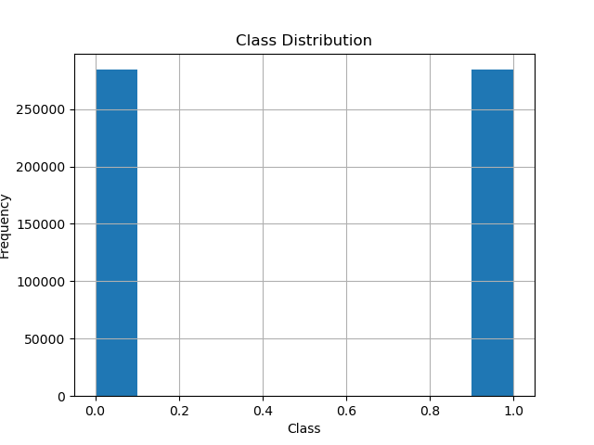The features were then evaluated to see if any transformation would be necessary to facilitate the model. 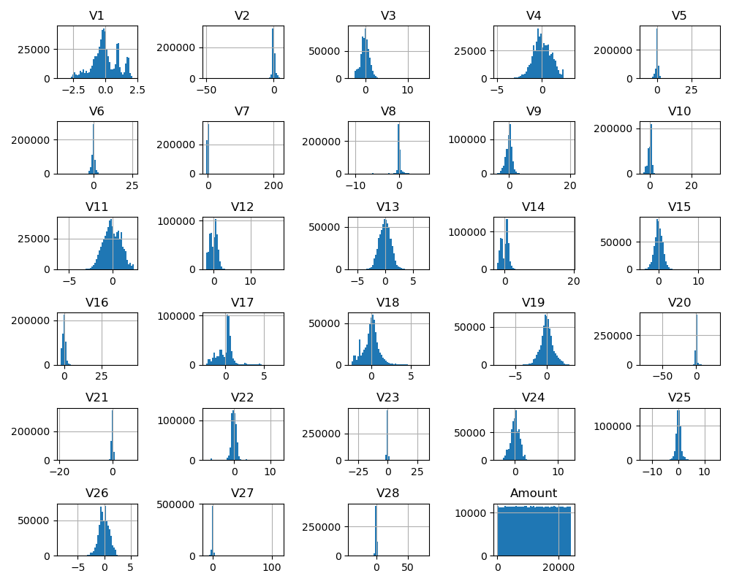
The distributions indicate the potential for outliers in several features. Since outliers are key to the analysis I will be skipping the normal outlier removal process.
There are also some highly skewed features, V2, V3, V5, V7, V9, V10, V12, V14, V16, V20, V21, and V27. These features will require additional handling before they are ready for modeling. I used a quantile transformation to adjust the skew while maintaining the outliers. The remaining features were processed through a standard scaler function to convert the data into the same form as the results of the quantile transformation.

Methods of Analysis
Four different models will be evaluated. These models will be compared to provide several options to the consumer.
- Logistic Regression
- Decision Tree
- Random Forest
- K-Nearest Neighbors

Models Considered

Logistic Regression
The logistic regression model was selected for its simplicity. The hope here is that it will provide a quick base line to compare the other three models to. Additionally, it should be the quickest to return the classification of a transaction. If this model is comparable to more complex models, this model will be useful for customers that prioritize speed.

Decision Tree
The decision tree model is the next simplest model. The hope here is that it has improved performance over the logistic regression model. The decision tree model also handles missing data well, this is extremely valuable. The decision tree is also the easiest to explain to executives as it can be displayed visually.

Random Forest
Random Forest was included since it is a variation on a decision tree. It should have more accuracy at the cost of speed. Like the decision tree, random forest handles missing data well.

K-Nearest Neighbors
K-Nearest Neighbors was selected mostly to see how it stacks up against the Decision Tree and Random Forest model. This model will likely be the slowest of the four being compared. Since this model relies on similar transactions for identification it has potential for additional customization in future iterations.

Model Comparison
The four models will be compared using Accuracy, F1-Score, Precision, and Recall. Accuracy and Precision were select since they represent how well the model is identifying fraudulent transactions. Recall is important since it represents how many fraudulent transactions have slipped through. F1-score represents an overall score for the model.
The optimum model will balance the four model performance metrics and speed.

Results and Findings

Logistic Regression
The logistic regression model did not converge with this data set after 100 iterations. No determinations can be made except for this model does not work.

Decision Tree
The first model that was able to produce results was Decision Tree. The model had an accuracy of 99.09%, a precision of 99.09%, a recall of 99.09%, and an F1-score of 99.09%.
The decision tree model completed in 8.92 seconds.

Random Forest
The next model to be run was the random forest. The model had an accuracy of 99.82%, a precision of 99.82%, a recall of 99.82% and an F1-score of 99.82%.
The model ran in 2:32.

K-Nearest Neighbors
The last model to be evaluated is the K-nearest neighbors. The model had an accuracy of 90.23%, a precision of 91.00%, a recall of 90.24%, and an F1-score of 90.19%.
The model ran in 10.7 seconds.

Evaluation
Between the three models that produced results the most accurate was Random Forest and the least accurate was K-Nearest Neighbors. Performance wise Decision Treen and Random Forest were similar in performance with Random Forest outperforming in all metrics by less than 1%.

Conclusion
Out of the three models I would recommend the Decision Tree due to its relatively high accuracy and quick processing time. This would be a good option for real time flagging the transaction. The Random Forest model would be good for post transaction processing to warn consumers about various transactions.
The model as it exists is not ready for deployment. Since the original data set appears to be curated to increase the number of fraudulent transactions. This model should be used to evaluate a new data set that has a more representative number of fraudulent transactions. Additionally, the original anonymized features will need to be mapped to the real features.
This model looks at the population as a whole, the next iteration of the model should be developed to use the whole population when a customer first signs up for a credit card and should transition to a model that is more tuned to their behaviors for a better customer experience.

Ethical Discussion
Since the work is with financial data there are several ethical considerations that need to be evaluated. The biggest one is the use of Personally Identifiable Information (PII). PII represents a concern since it could allow malicious actors to impersonate an individual and thus cause more fraud. This is alleviated by the fact that the data has been anonymized. In this case all of the data has been converted into numbers. This anonymization of the data does raise some risks about the data itself. The anonymization could have skewed the data. Since we do not know the original data the impact is unknown.

References
[1] https://www.ftc.gov/news-events/news/press-releases/2025/03/new-ftc-data-show-big-jump-reported-losses-fraud-125-billion-2024
[2] https://www.security.org/digital-safety/credit-card-fraud-report/
[3] https://medium.com/@rtjeannier/whats-the-point-of-pca-anyway-279cf0ef0683

